**CODE:**

library(dplyr)

subject1 <- c(45,67,22,78)

subject2 <- c(46,78,45,89)

attendance <- c(67,43,34,58)

marks_summary1 <- data.frame(subject1,subject2,attendance)

z=filter(marks_summary1,marks_summary1$subject1>50)

print(z)

**OUTPUT:**

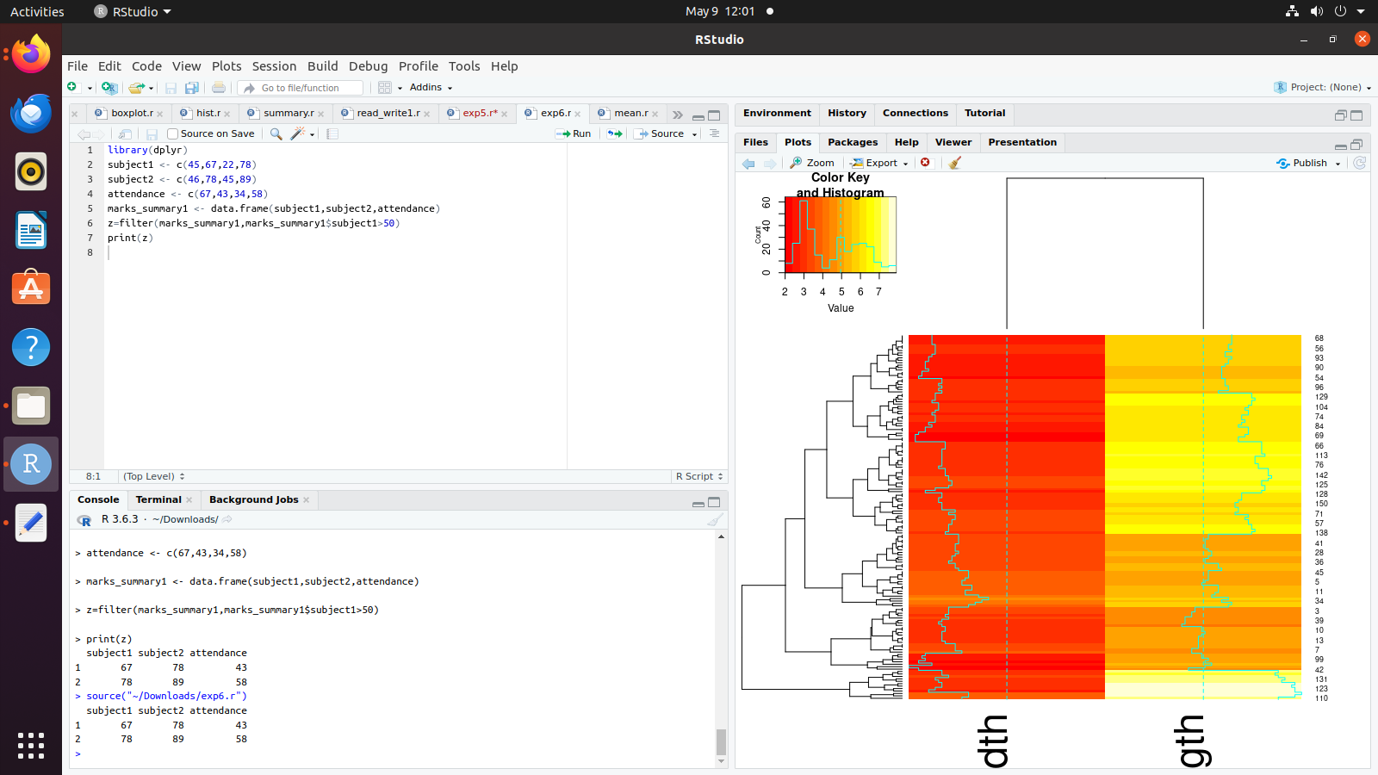

**CODE:**

library(dplyr)

it1 <- c(17,17,16,18)

it2 <- c(12,16,16,18)

attendance <- c(40,75,78,88)

marks_summary1 <- data.frame(it1,it2,attendance)

z=distinct(marks_summary1, it1, .keep_all = TRUE)

print(z)

**OUTPUT:**

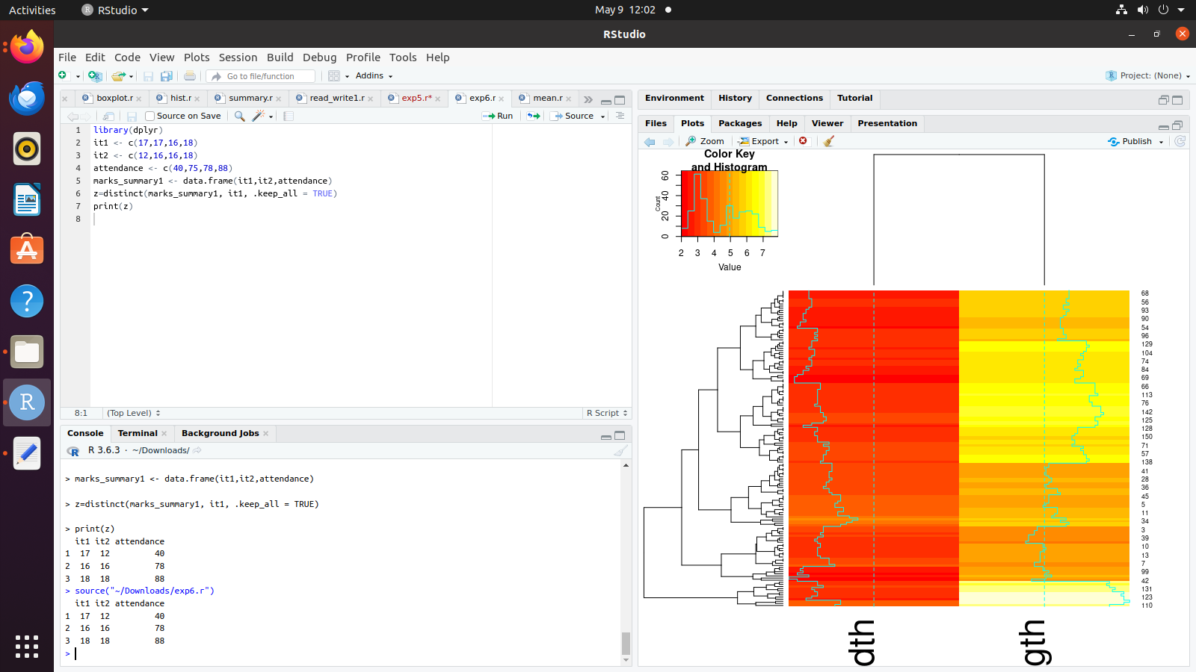

**CODE:**

library(dplyr);

rollno<-c(2,33,55,15);

it1 <- c(17,17,16,18);

it2 <- c(12,16,16,18);

attendance <- c(40,75,78,88);

marks_summary1 <- data.frame(rollno,it1,it2,attendance)

z=arrange(marks_summary1,rollno)

print(z)

**OUTPUT:**

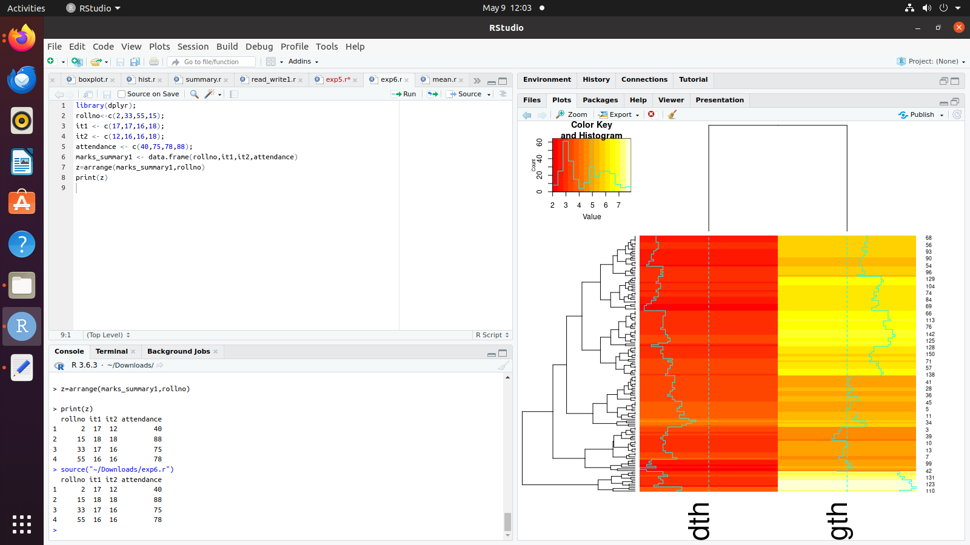

**CODE:**

library(dplyr)

it1 <- c(17,17,16,18)

it2 <- c(12,16,16,18)

attendance <- c(40,75,78,88)

marks_summary1 <- data.frame(it1,it2,attendance)

z=select(marks_summary1,it1,it2)

print(z)

**OUTPUT:**

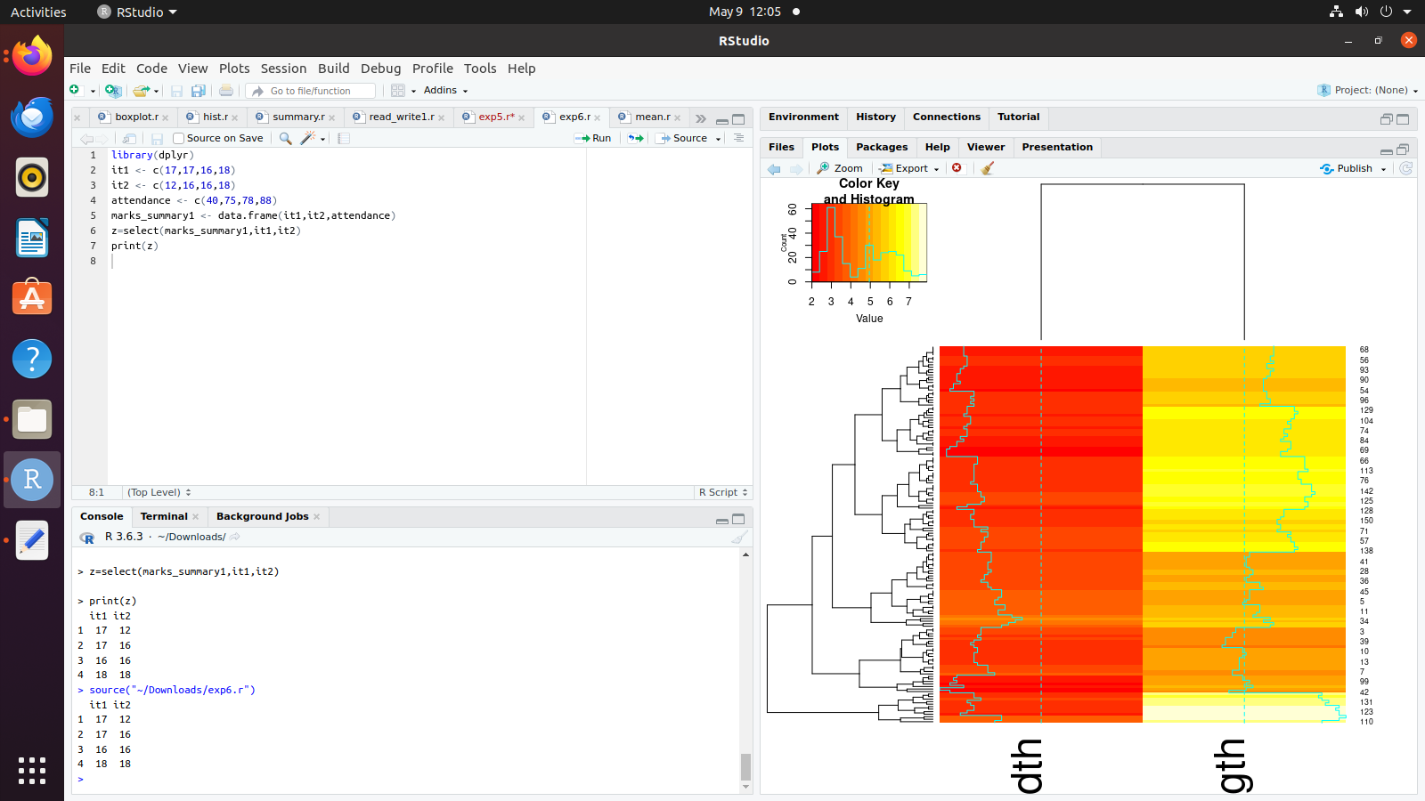

**CODE:**

library(dplyr)

it1 <- c(17,17,16,18)

it2 <- c(12,16,16,18)

attendance <- c(40,75,78,88)

marks_summary1 <- data.frame(it1,it2,attendance)

z=rename(marks_summary1,stud_att=attendance)

print(z)

**OUTPUT:**

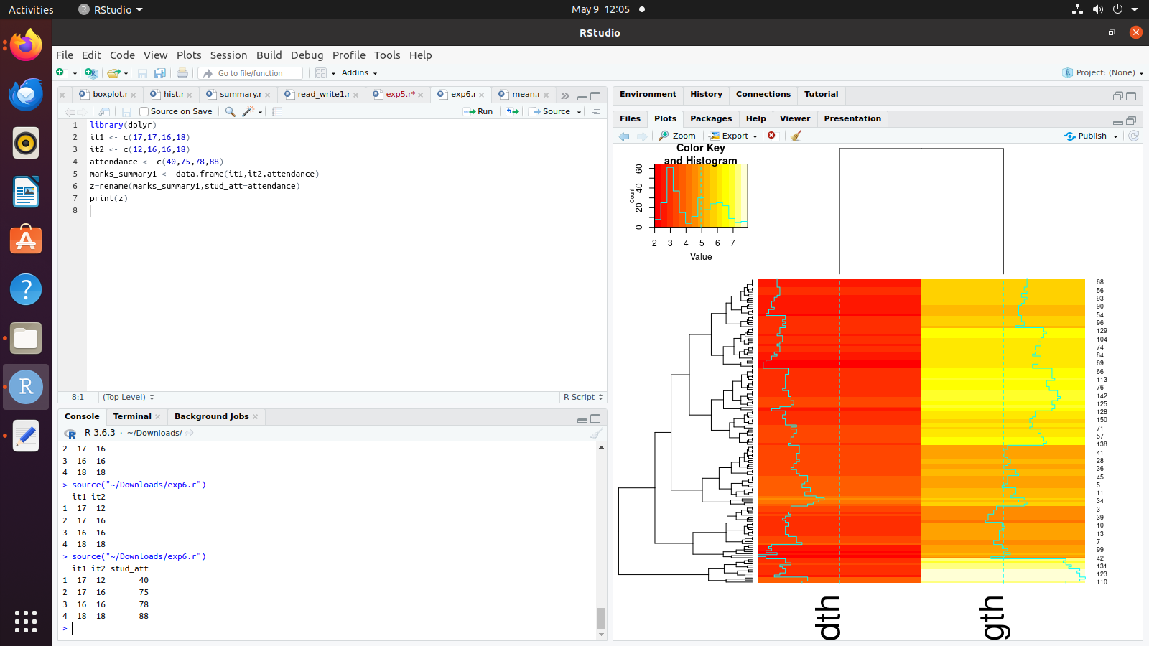

**CODE:**

library(dplyr)

it1 <- c(17,17,16,18)

it2 <- c(12,16,16,18)

attendance <- c(40,75,78,88)

marks_summary1 <- data.frame(it1,it2,attendance)

z=mutate(marks_summary1,avg=(it1+it2)/2)

y=transmute(marks_summary1,avg=(it1+it2)/2)

print(z)

print(y)

**OUTPUT:**

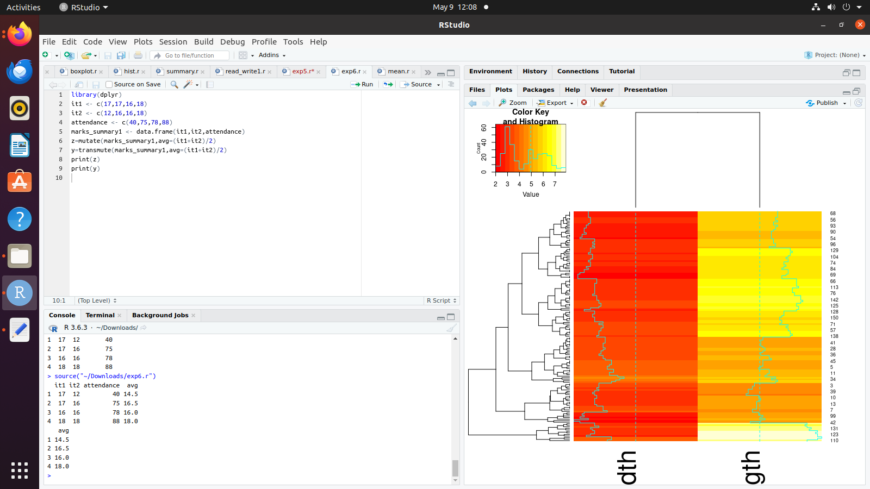

**CODE:**

library(dplyr)

it1 <- c(17,17,16,18)

it2 <- c(12,16,16,18)

attendance <- c(40,75,78,88)

marks_summary1 <- data.frame(it1,it2,attendance)

z=summarize(marks_summary1,mean(it1),mean(it2),median(it1),median(it2),sd(it1))

print(z)

**OUTPUT:**

